PERSONAL INFORMATION | Fatma CHERIF
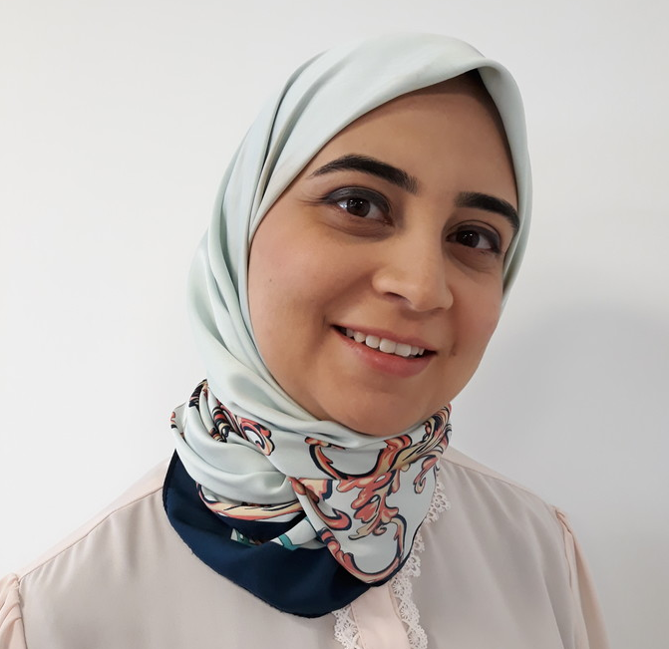 | (Tunisia)
 | (+216) 20283580
 | chrif.fatma@gmail.com
https://www.linkedin.com/in/fatma-cherif-tn/

SUMMARY

A servant leader, certified Professional Scrum Master and certified Professional Scrum Product owner with eleven years of experience in the technology field. Worked in several positions within multinational companies. Strong negotiation, organizational, and verbal communication skills. Excellent team player with strong leadership and mentoring skills.

WORK EXPERIENCE

March 2019 - Present  Sep 2017–Jan 2019 | Line solution manager & Agile coach  Sofiatechnologies, Tunis (Tunisia)  - Coordinate information and activities between Mobile, Web, embedded, backend, hardware teams,  - Track projects progress,  - Analyze and manage risks,  - Set project roadmap according to available resources and deadlines,  - Identify, record, and manage changes in projects scopes,  - Estimate and track projects cost,  - Manage end-clients and ensure their satisfaction  - Gather functional requirements from stakeholders,  - Motivate collaborators,  - Train engineers and organization in agile framework (Scrum, Kanban)  - Guide collaborators on how to use Agile and Scrum practices and values ​to delight customers and to get the most out of self-organization,  - Detect and resolve conflicts between collaborators,  - Coach scrum masters/product owners in efficient process techniques and best practices.  Project coordinator & scrum master
 | itemis Tunisie, Tunis (Tunisia)
- Coordinate executional tasks of several projects that span over Mobile, Web, embedded, backend, hardware, and mechanical design teams,
- Track IoT projects progress and detect delivery risks,
- Plan IoT projects work according to available resources and deadlines,
- Improve usability of web applications and IoT products,
- Reduce loss of information by writing relevant technical documentation,
- Identify, record, and manage changes in projects scopes,
- Facilitate scrum events,
- Guide collaborators on how to use Agile and Scrum practices and values ​to delight customers and to get the most out of self-organization,
- Detect and resolve conflicts between collaborators.

Feb 2016–Aug 2017 | Software Engineer Specialist
 | FIS global, Tunis (Tunisia)
- Implement financial services in the MarketMap financial solution developed with C++,
- Conduct meetings with business analysts to understand specifications,
- Investigate the causes of non-conforming results and developed solutions,
- Develop and automated test cases to improve test procedures,
- Wrote detailed and well-structured test and configuration procedures,
- Work with Agile/Scrum development process

Apr 2015–Jan 2016 | Application and Support Engineer
 | STMicroelectronics, Tunis (Tunisia)
- Support FAEs (Field Application Engineer) and STM32 micro-controllers forums’ users within 72 hours deadline,
- Reproduce accurately hardware and software bugs then provided solutions for STM32 customers,
- Interact with development team to analyze software bugs,
- Increase the online support in STM32 microcontroller forums by 50% after a long-time of poor support
- Increase the number of issues reported in forums as it became a trustful channel of support for customers
- Increase by 50% the number of issues reported for enhancement coming from forums.

Jun 2011–Apr 2015 | Software Engineer
 | STMicroelectronics, Tunis (Tunisia)
- Model with C++/SystemC library of registers at Transaction Level Model that accelerate test process on System On Chip platforms.
- Develop Test modules to browse thoroughly implemented code and detect failures,
- Write detailed specification documentation,
- Support newcomer engineers and improved their autonomy.

Oct 2009–May 2011 | CAD Engineer
 | STMicroelectronics, Tunis (Tunisia)
- Develop with Skill++ the layouts of Parameterized Cells (manufacturing masks), which are electric configurable components.
- Promote within six months to other tasks on new 32nm/14nm technology due to strong ability of multi-task.
- In research phase of new 32nm/14nm technology, check electric parameters of components.
- Write new detailed documentation describing check process.

EDUCATION

Sep 2006–Jun 2009 | Electronics Engineering
 | National School of engineers, Sfax, Sfax (Tunisia)

PERSONAL SKILLS

Foreign language(s) | UNDERSTANDING |  | SPEAKING |  | WRITING
 | Listening | Reading | Spoken interaction | Spoken production
French | C1 | C1 | C1 | C1 | C1
English | C1 | C1 | B2 | B2 | C1
Arabic | C2 | C2 | C1 | C1 | C1
 | Levels: A1 and A2: Basic user - B1 and B2: Independent user - C1 and C2: Proficient user

Communication skills | Strong communication skills gained through experience and several trainings:  - Active Listening: May 2017, Smart Future Center  - Certification of technician in hypnotherapy and Pedo-Hypnotherapy: June, 2014, Ecole de formation Professionnelle en Hypnotisme du Québec en Tunisie.  - Certification of practitioner in Neuro Linguistic Programming (NLP): March, 2011, AL-HAKIM center.  - Negotiation, Lobbying, Techniques of non-violent communication: March 2015, Search For Common Ground Organization  - Emotional intelligence  - The Pathway to Excellence, Ten keys of success: 2008, Canadian Training Center of Human Development

Organisational / managerial skills | Good organisational skills - currently coordinating work between several teams, gained through experience and trainings:  - Certification Professional Scrum Product Owner: December, 2019 (Link)  - Certification Professional Scrum Master: December, 2018 (Link)  - Stress management: December, 2010, Ariane Management and RH  - Management of time and priorities: October, 2010, AL-HAKIM center

Job-related skills | - Agile projects management  - Usability and Design Thinking trainings  - 3D printing of mechanical prototypes  - System Versioning: Git, Source Safe, Synchronicity, SVN  - Tools: Cadence, Virtualizer, STM32CubeMx, Keil, IAR Embedded Workbench, SW4STM32, VMware, Visual Studio, Jira

